
Ridesharing App
The development team of company X has received a new project. They must implement a ridesharing system, so the end users can book a trip using someone’s shared car. The end users will interact with the system via a mobile app. The mobile app will communicate with a back end app using REST. The data will be stored in an SQL database.
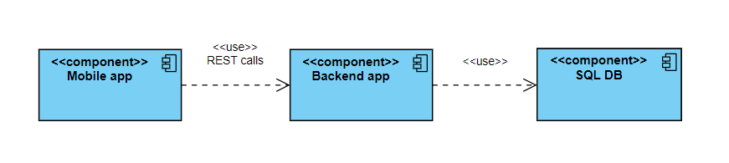
The first requirements for the back end app are to provide endpoints that can facilitate:
- Adding a driver
- Updating a driver
- Adding a trip
- Getting the list of all trips for a driver
The following business rules need to be in place for each endpoint:
- Adding a driver: the request body and response body are mapped according to the table below:
Field name | Present on the request | Mandatory on request | Present on response | Other validations
id | no | no | yes | PK, auto-generated on DB level
name | yes | yes | yes | String with max length of 100
email | yes | yes | yes | unique (you cannot add 2 drivers with the same email)
city | yes | yes | yes | String with max length of 100

- Updating a driver: driverId is in the path, the request body and response body are mapped according to the table below:
Field name | Present on the request | Mandatory on request | Present on response | Other validations
id | yes | yes | yes | Cannot be updated
name | yes | yes | yes | String with max length of 100
city | yes | yes | yes | String with max length of 100
email | no | no | yes

- Adding a trip: the request body and response body are mapped according to the table below:
Field name | Present on the request | Mandatory on request | Present on response | Other validations
id | no | no | yes | PK, auto-generated on DB level
fromAddress | yes | yes | yes | String with max length of 200
toAddress | yes | yes | yes | String with max length of 200
driverId | yes | yes | yes | FK to an existing driver. If the driver doesn’t exist, the trip cannot be created

- Getting the list of all trips for a driver: driverId is provided in the url, no request body, and the response is mapped according to the table below:
Field name | Present on the request | Mandatory on request | Present on response | Other validations
id |  |  | yes
fromAddress |  |  | yes
toAddress |  |  | yes
driverId |  |  | yes

Unit tests should be implemented for the service methods, with a coverage of at least 70%.
The type of the SQL DB is chosen by the development team.

